Zoom whatsapp integration:

Connecting to WhatsApp…

Zoom Contact Center supports Social Messaging platforms as an additional channel. Currently, we support Meta Messenger (previously known as Facebook Messenger) and WhatsApp.

1. Navigate to https://marketplace.zoom.us and ensure you’re logged in as your pre-configured Supervisor (Sundarapandian).

2. Use the search function at the top of the page to search for “whatsapp”.

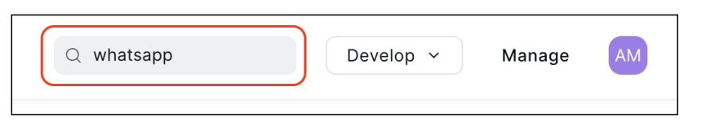

3. Select the WhatsApp Business Connector from the search results.

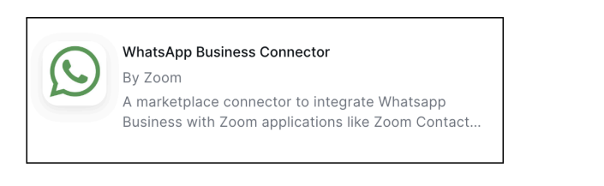

4. Click on the Create Connector button, followed by the Connect button

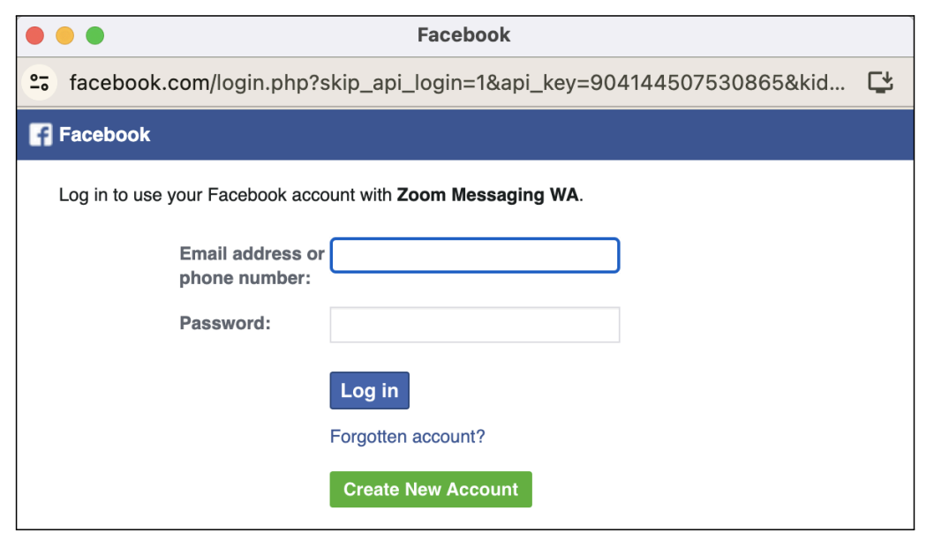

5. Close the Facebook/WhatsApp login / pop-up window as we will not complete the Meta authorization process in this lab.

Remaining steps to perform on a customer’s account…

To complete the WhatsApp Social Messaging integration, you would perform the additional steps below on the customer’s account. In this lab these are provided for reference, you will not actually complete these steps.

1. Complete the Meta Facebook/WhatsApp authorization process that you started above.

2. Link a phone number that is already on your Zoom Contact Center account with WhatsApp.

During the phone number registration process on WhatsApp, you will provide a phone number to WhatsApp, and they will perform a validation/verification process to ensure that you own the number. An example of that verification process is shown below.

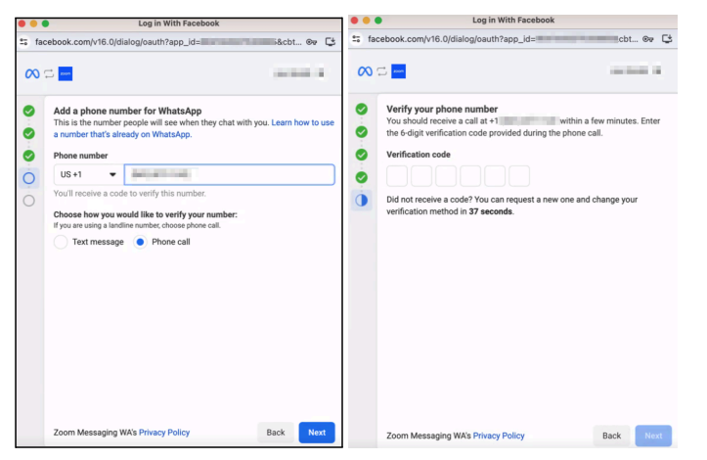

3. Once you complete the verification process, the connection between ZCC & WhatsApp will be established.

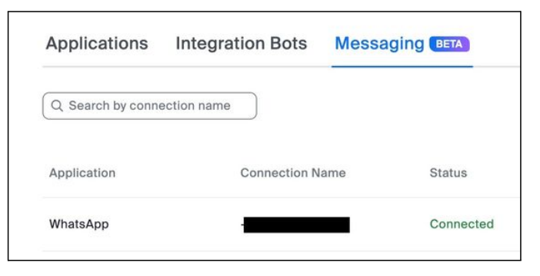

4. Finally, you will create a new Messaging Flow within Zoom Contact Center, and assign the WhatsApp verified number to the flow.

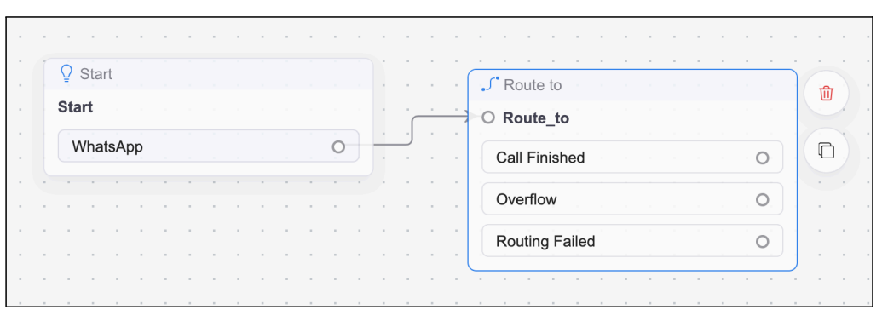

5. At that point, consumers can go into WhatsApp and send a message to the verified phone number. The message will then be transmitted from WhatsApp to Zoom Contact Center, routed through the Flow, and to the appropriate queue/agent.

